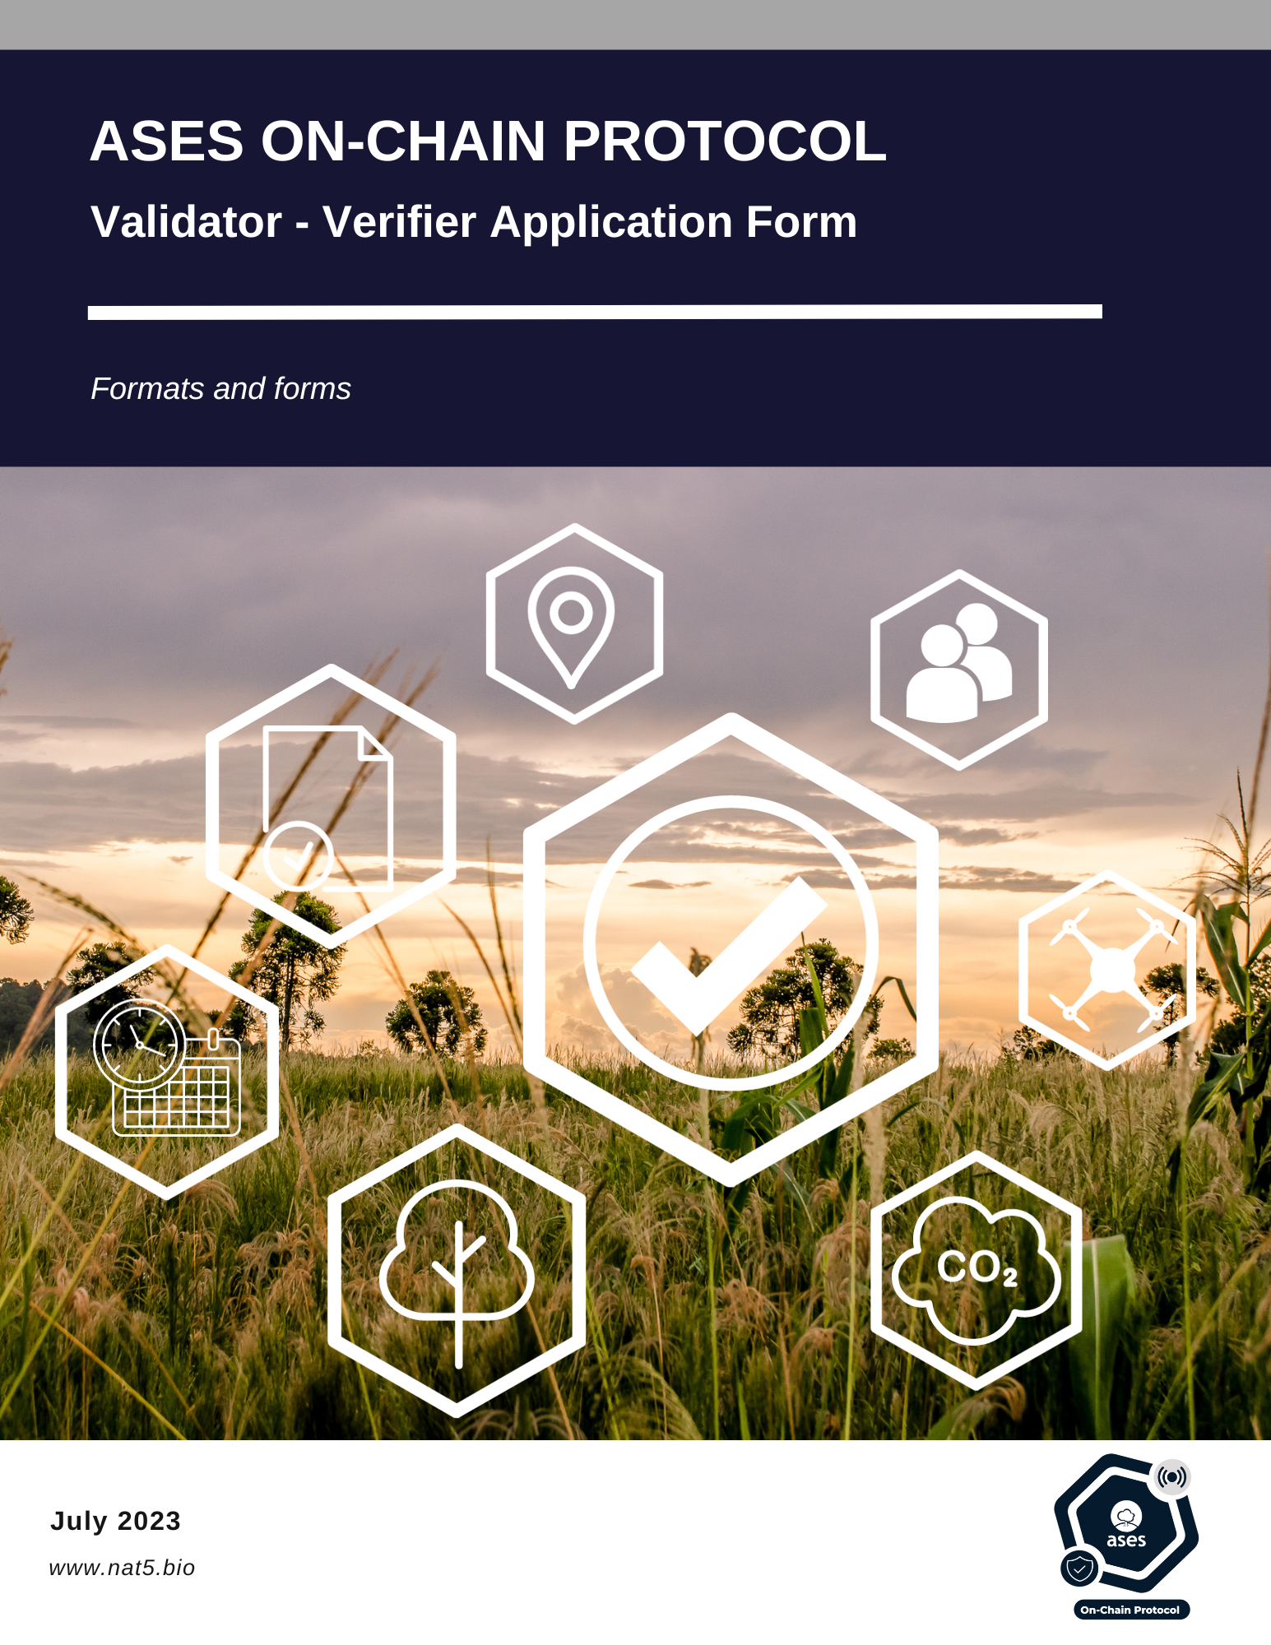

|  |  |
| --- | --- |
| **General Information** | |
| Date | *Date of submission* |
| Name of applicant | *Name of organization submitting application* |
| Organization representative | *Name of person responsible for validations/verifications* |
| Location | *Physical address of applicant* |
| Main contact (to be listed on aOCP website) | *Contact name, email address, phone number, web-address* |
| Finance contact (for purposes of submitting invoice for Approval fee) | *Contact name, email address and phone number* |
|  |  |

|  |  |  |
| --- | --- | --- |
| **Stage of Application** | | |
| Application for  (check all that apply) |  | Third independent validating part |
|  | Third independent verified part |
|  |  |  |

|  |  |
| --- | --- |
| **Valid Accreditation Information** | |
| Accreditation / certification | *Please list the accreditations that your company holds* |
| Accrediting organisation | *Please provide details of the organisation that has accredited your organisation and provide the name and the address and the contact details of the contact person from the accreditation body.* |
| Validity of accreditation | *Please mention the date of validity of accreditation.* |
| Sectoral scopes | *Please mention (in Table 1 or/and 2) all the GHG sectoral scopes (GHG-SS) for which your organisation has a valid accreditation for validation and verification as on the date of signature this form. Provide and attach evidence of the information provided. This may include accreditation certificates and/or URL for official listing on accrediting entity’s website.* |

|  |  |  |  |
| --- | --- | --- | --- |
| **Table 1** | **Valid Accreditation** | | |
| **Area** | **Sectoral scopes** | **Validation** | **Verification** |
| Accreditation Standard[1] | (check all that apply) | (check all that apply) |
| **Green House Gas (GHG)** | 1. Energy (renewable/non-renewable sources) (CDM TA 1.1, 1.2) |  |  |
| 1. Energy distribution (CDM TA 2.1) |  |  |
| 1. Energy demand (CDM TA 3.1) |  |  |
| 1. Manufacturing industries (CDM TA 4.1) |  |  |
| 1. Chemical industry (CDM TA 5.1, 5.2) |  |  |
| 1. Construction (CDM TA 6.1) |  |  |
| 1. Transport (CDM TA 7.1) |  |  |
| 1. Mining/mineral production (CDM TA 8.1) |  |  |
| 1. Metal production (CDM TA 9.1, 9.2) |  |  |
| 1. Fugitive emissions from fuels (solid, oil and gas) (CDM TA 10.1) |  |  |
| 1. Fugitive Emissions from production and consumption of halocarbons and sulphur hexafluoride (CDM TA 11.1, 11.2) |  |  |
| 1. Solvents use (CDM TA 12.1) |  |  |
| 1. Waste handling and disposal (CDM TA 13.1, 13.2) |  |  |
| 1. Afforestation and Reforestation(CDM TA 14.1) |  |  |
| 1. Agriculture (CDM TA 15.1) |  |  |
| 1. Carbon Capture and Storage of CO2 in Geological Formations (CDM TA 16.1) |  |  |
|  |  | | |
| **Table 2** | **Valid Accreditation provided by National Accreditation body (NAB)** | | |
| **Area** | **Sectoral scopes** | **Validation** | **Verification** |
| As per IAF MD14[2] document for ISO 14064-2 | (check all that apply) | (check all that apply) |
| **Green House Gas (GHG)** | Energy Industries (renewable/non-renewable sources) |  |  |
| Energy Distribution |  |  |
| Energy Demand |  |  |
| Manufacturing Industries |  |  |
| Chemical Industry |  |  |
| Construction |  |  |
| Transport |  |  |
| Mining/Mineral Production |  |  |
| Metal Production |  |  |
| Fugitive Emissions from Fuels (solid, oil and gas) |  |  |
| Fugitive Emissions from Production and Consumption of Halocarbons and Sulphur Hexafluoride |  |  |
| Solvents Use |  |  |
| Waste Handling and Disposal |  |  |
| Afforestation and Reforestation |  |  |
| Agriculture |  |  |
| Carbon Capture and Storage of CO2 in Geological Formations |  |  |

|  |  |  |  |
| --- | --- | --- | --- |
| **Request for Approval as aOCP Validator/Verifier for the scopes** | | | |
| *Please fill this section to mention the scopes, for which you have the competency, and you wish to apply and request* *approval from aOCP.*  *Provide description to demonstrate the competency for the aOCP scopes (GHG,**biodiversity, water (optional) and SDG) and applicable GHG-SS & TA, you have opted in the tables below. The competence may be demonstrated on the basis of knowledge, skill and experience. This may for example be demonstrated on the basis of various qualifications, certificates, CV review, examinations. Also provide evidence of the information provided in the tables above. This may include accreditation certificates and/or URL for official listing on accrediting entity’s website. Provide list of all staff having required competencies and provide mapping with aOCP scopes (GHG,**biodiversity, water (optional) and SDG) and applicable GHG SS & TA to qualify personnel.* | | | |
| **aOCP Scopes** | **Requirements** | **Compliance** | **Experience details** |
| **Green House Gas[3] (GHG)** | aOCP requires demonstration of valid accreditation for the sectoral scopes (SS) and corresponding technical areas (TA), within each sectoral scope, as defined by ‘*Procedure for Approval of aOCP Validators/Verifiers*’. Please confirm and complete information in Table 3[4]. |  | *Please detail the experience and if you have evidence, attach it to the form.* |
| **Biodiversity** | aOCP requires demonstration of knowledge and skills to assess biodiversity. |  | *Please detail the experience and if you have evidence, attach it to the form.* |
| **Environmental No-harm** | aOCP requires demonstration of competence on application of aOCP rules related to environmental aspects as defined by ‘*Environment and Social Safeguards Standard’* |  | *Please detail the experience and if you have evidence, attach it to the form.* |
| **Social No-harm** | aOCP requires demonstration of competence on application of aOCP rules related to social aspects as defined by ‘*Environment and Social Safeguards Standard’* |  | *Please detail the experience and if you have evidence, attach it to the form.* |
| **Water restoration (Soil hydraulic properties)** | aOCP requires (for Validators/verifiers willing to be accredited for water-restoration projects) demonstration of knowledge and skills for the assessment of soil hydraulic properties. |  | *Please detail the experience and if you have evidence, attach it to the form.* |
| **Sustainable Development Goals (SDG)** | aOCP requires demonstration of competence on application of aOCP rules related to United Nations Sustainable Development Goals |  | *Please detail the experience and if you have evidence, attach it to the form.* |

|  |  |
| --- | --- |
|  |  |
| **Confirmation on Compliance with aOCP Rules** |
| Eligibility of application  *I/we confirm that I/we have completely met all the applicable requirements for application as aOCP Validator/Verifier as mentioned in the ‘Procedure for Approval of aOCP Validators/Verifiers’ and that all the information provided in the signed and stamped ‘aOCP Validator/Verifier Application Form’ is correct and ‘aOCP Validator/Verifier Agreement’ is completely understood and agreed.* |
| Compliance of requirements during Validation/Verification  *I/we confirm that I/we have clear action plans in place to meet all the requirements during operations to conduct validations/verifications as aOCP Validator/Verifier as mentioned in the ‘Procedure for Approval of aOCP Validators/Verifiers’ and ‘aOCP Validator/Verifier Agreement’.* |
| Compliance of aOCP Rules  *I/we confirm that I/we shall always comply with all the requirements as mentioned in the applicable ‘aOCP Rules’ as available publicly on aOCP website. In case our accreditation status with CDM or NAB changes, we will immediately notify aOCP. We will not provide any validation/verification service; in case our accreditation is not valid, or we don’t have competence as per the aOCP scopes including the GHG sectoral scope of the technical areas required.* |
| Avoiding conflict of interest in the validation/verification of aOCP projects  *I/we confirm that I/we shall not conduct Project Validation and Emission Reduction/Removal, Biodiversity and Water Verification for the same project activity. I confirm that, in case of any conflict of interest, the organization or person will not be deployed to perform the validation/verification.* |

Signed for and on behalf of:

Name of entity: _______________________­­­­­___________

Signature with stamp: _______________________­­­­­___________

Name of signatory: _______________________­­­­­___________

Date: _______________________­­­­­___________

|  |  |  |
| --- | --- | --- |
| **DOCUMENT HISTORY** | | |
| **Version** | **Date** | **Comments** |
| V1.0 | 11/01/2023 | * Initial version released for review by the aOCP Steering Committee under the aOCP Version 1. |
| V2.0 | 20/07/2023 | * Second version released for review by the aOCP Steering Committee under the aOCP Version 1. |

1. CDM Accreditation Standard in Appendix 2
2. IAF MD 14 Document: <https://www.iaf.nu/upFiles/IAF_MD_Appln_17011_GHGVV_09072014_Publication_Version.pdf>
3. The aOCP scope for GHG is mandatory and a minimum requirement while applying as a aOCP validator/verifier
4. In doing this, you may refer to ‘Equivalence of Sectoral scopes (SS) and corresponding Technical Areas (TA)’ given in ‘Procedure for Approval of aOCP Validators/Verifiers’