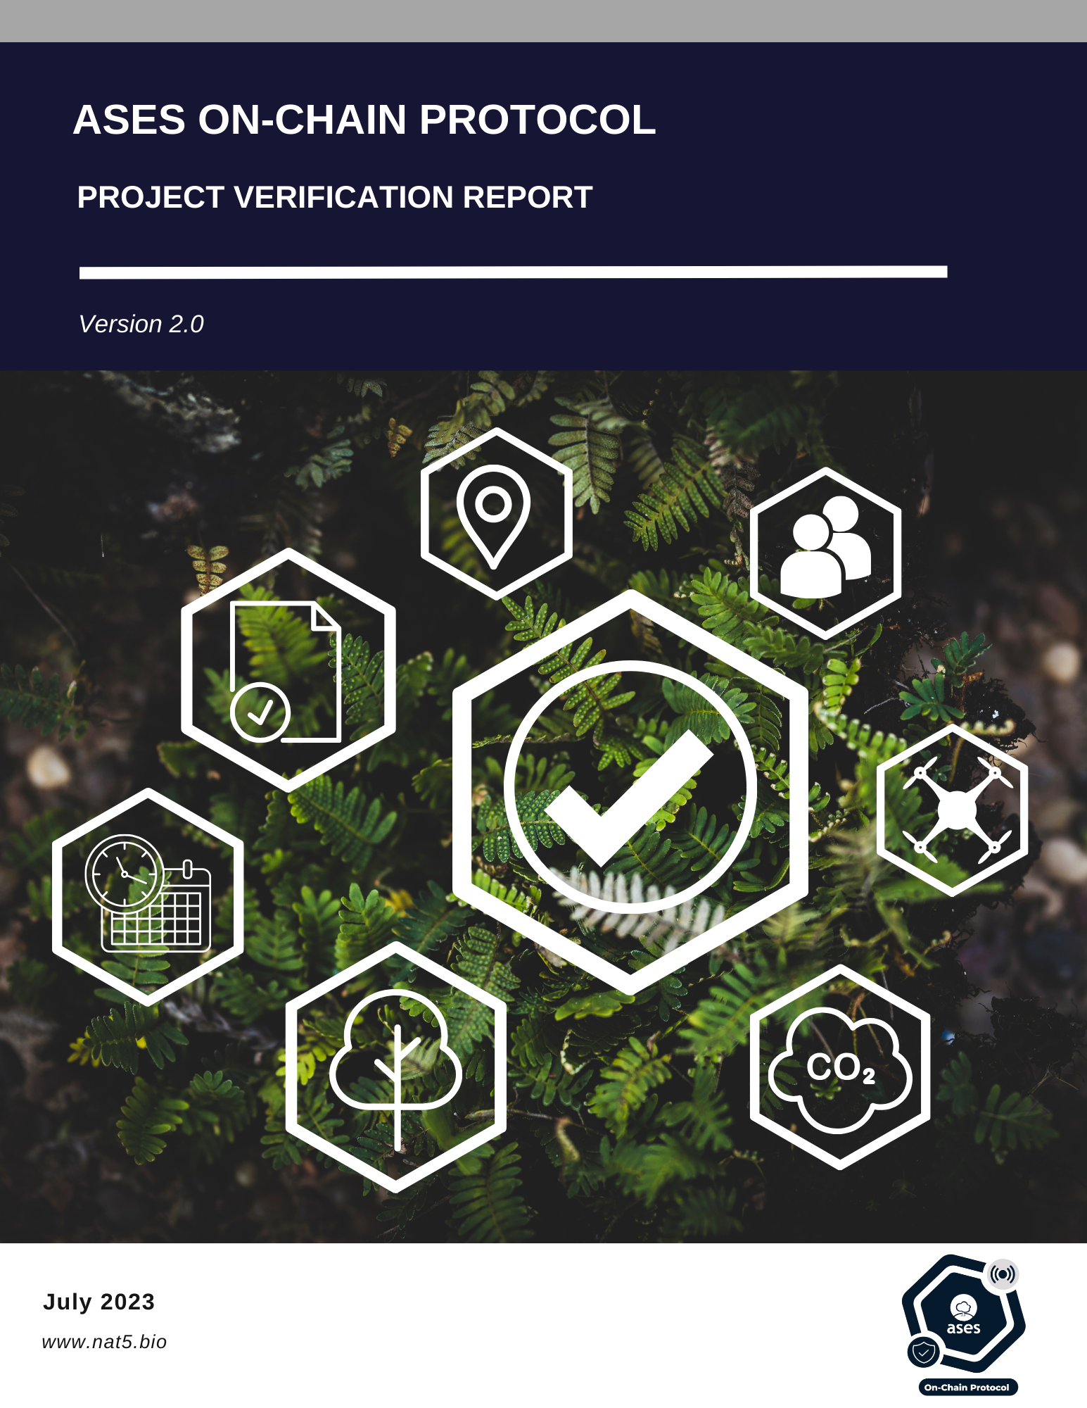

|  |  |
| --- | --- |
| **aOCP Project Verification Report Form (PVR)** | |
| *Complete this form in accordance with the instructions.* | |
| **Verifier information** | |
| **Name of approved aOCP Project Verifier / Reference No.**  (also provide weblink of approved aOCP Certificate) |  |
| **Unique validator/verifier registry key** |  |
| **Project information** | |
| **Title of the project activity** |  |
| **Key project** |  |
| **Project Developer** |  |
| **Project modality** | Modality A  Modality B |
| **Verification period** | 1  2  3  4  5  6  7  8  9  10 |
| **Type of project** | Forest management  Regenerative agriculture  Silvopastoral management  Individual tree-based climate action / urban forest  Water flow restoration  Biochar |
| **Type of VNPCs the project is applying for** | Carbon Removal and/or Emissions Reduction(VCC)  Biodiversity Based Credit (VBBC)  Water Credits (VWC)  Soil Credits (VSC) |
| **Country(ies) where the project is located** |  |
| **GPS coordinates of the Project site(s)’ centroid (one for each polygon).**  **In WGS84 and decimal degrees format.** |  |
| **Applied methodologies** | aOCP Methodology for water balance assessment V2.0  aOCP Methodology for soil and erosion assessment V2.0  aOCP Methodology for biodiversity assessment V2.0  aOCP Methodology for carbon removal and storage in vegetation V1.0  aOCP Methodology for biochar V1.0  aOCP Methodology for carbon capture monitoring V1.0 |

# Project verification report

## Section A. Executive Summary

## Section B. Issue information

|  |  |  |  |  |  |  |  |  |  |  |  |  |
| --- | --- | --- | --- | --- | --- | --- | --- | --- | --- | --- | --- | --- |
| **Water credits issued annually** | | | | | | | | | | | | |
| **Project Size**  **(Cubic meters)** | **After project implementation** | **2024** | **2025** | **2026** | **2027** | **2028** | **2029** | **2030** | **2031** | **2032** | **2033** | **Total** |
| Percentage of VWCs issued on each year (%) |  |  |  |  |  |  |  |  |  |  |  |  |
| **Monitoring period** |  |  |  |  |  |  |  |  |  |  |  |  |
| **Soil credits issued annually** | | | | | | | | | | | | |
| **Project Size (tons)** | **After project implementation** | **2024** | **2025** | **2026** | **2027** | **2028** | **2029** | **2030** | **2031** | **2032** | **2033** | **Total** |
| Percentage of VSCs issued on each year (%) |  |  |  |  |  |  |  |  |  |  |  |  |
| **Monitoring period** |  |  |  |  |  |  |  |  |  |  |  |  |

## Section C. Involved in the project certification process

Table 1. Involved in the project certification process

|  |  |  |  |  |  |  |  |
| --- | --- | --- | --- | --- | --- | --- | --- |
| **No.** | **Role** | **Last name** | **First name** | **Involvement in** | | | |
| **aOCP Internal team of technical experts** | **Third independent part** | **Project developer** | **aOCP Steering committee** |
| 1. | Verification Team Leader |  |  |  | **✓** |  |  |
| 2. | Leader of the internal team of technical experts | Alejandra | Verde | **✓** |  |  |  |
| 3. | Legal representative of the project developer |  |  |  |  | **✓** |  |
| 4. | Steering committee representative | Guillermo | Hinojos |  |  |  | **✓** |

## Section D. Project Verification Findings

Fill out the tables in sections D.1 through D.14 below to verify compliance with the appropriate Project Verification standards in the aOCP Validation and Verification Standard and Project Standard by describing:

* Means of Project Verification: describe how compliance has been verified;
* Determine whether or not the project is in compliance.

### D.1. Monitoring reports

Were the quarterly reports stipulated in the monitoring plan completed and is there documentary evidence of this?

|  |  |
| --- | --- |
| **Means of Project Validation** |  |
| **Conclusion** | Compliance  In non-compliance |

### D.2. Project Activities

The developer submitted the Annual Activity Report with evidence of activities (if applicable).

|  |  |
| --- | --- |
| **Means of Project Validation** |  |
| **Conclusion** | Compliance  In non-compliance  Not applicable |

### D.3. Project Implementation

Has the Project been implemented as reported in the registered PSF?

|  |  |
| --- | --- |
| **Means of Project Validation** |  |
| **Conclusion** | Compliance  In non-compliance  Not applicable |

### D.4. Risk assessment and follow-up action

Risk mitigation measures were implemented according to the risk management plan (if applicable).

|  |  |
| --- | --- |
| **Means of Project Validation** |  |
| **Conclusion** | Compliance  In non-compliance  Not applicable |

### D.5. Safeguards

The developer has applied the safeguards defined in the PSF to provide protection against negative impacts to ecosystems or society and the Project Activity has caused no net harm to the environment or society.

|  |  |
| --- | --- |
| **Means of Project Validation** |  |
| **Conclusion** | Compliance  In non-compliance |

### D.6. Calculations

Accuracy of calculations:

* **Carbon removal:** The number of carbon credits is not higher than the carbon checker;
* **Biodiversity:** was the survey done on-site? Is there evidence in the monitoring report?
* **Soil erosion:** aOCP's internal team of technical experts performed the survey. Is there evidence of the works? does the report include evidence of the data rasters used? and evidence (photographic and cartographic annexes, databases, spreadsheets, and reports are clearly presented facilitating the reproducibility of the calculations);
* **Soil health:** were laboratory analyses performed?;
* **Water:** does the report include evidence of the rasters used and the precipitation data? and evidence (photographic and cartographic annexes, databases, spreadsheets, and reports are clearly presented facilitating the reproducibility of the calculations).

|  |  |
| --- | --- |
| **Means of Project Validation** |  |
| **Conclusion** | Compliance  In non-compliance |

### D.7. Type of VNPCs the project is applying

Does the monitoring report cover all types of credits requested by the developer?

|  |  |
| --- | --- |
| **Means of Project Validation** |  |
| **Conclusion** | Compliance  In non-compliance |

### D.8. Standards and procedures

Has the project complied with aOCP Standards and Procedures?

|  |  |
| --- | --- |
| **Means of Project Validation** |  |
| **Conclusion** | Compliance  In non-compliance |

### D.9. Evidence of information

Are the arguments and evidence presented sufficient and of adequate quality? If not, raise Technical Modification Request or Request of Supplementary Information.

|  |  |
| --- | --- |
| **Means of Project Validation** |  |
| **Conclusion** | Compliance  In non-compliance |

# Section E. Verifier's opinion

Table 3. Project verification

|  |  |  |
| --- | --- | --- |
| **Verifier name** |  | **Date:** |
| **Verifier's conclusion** | | |
| The project demonstrates the expected benefits, providing the necessary evidence for verification. | | |
| **Verifier's opinion** | | |
| **Approved** (the project is meeting the expected capture/benefits and is approved for issuance of credits.)  **Not approved** (the verifier's opinion is not favorable as the project has not met the expected capture/benefits and the issuance of credits cannot be made).  **Additional information** (the information/evidence provided for the verification is not enough) | | |

|  |
| --- |
| If the project is "not approved" or requires "additional information", please detail the technical justification and the need for additional information. Specify if it is a Technical Modification Request or a Supplementary Information Request. |
|  |

|  |
| --- |
| **Name and signature of validator** |
|  |

|  |  |  |
| --- | --- | --- |
| **DOCUMENT HISTORY** | | |
| **Version** | **Date** | **Comments** |
| V2.0 | 10/10/2023 | * Second version released for review by the aOCP Steering Committee under the aOCP Version 2. |
| V1.0 | 25/01/2023 | * Initial version released for review by the aOCP Steering Committee under the aOCP Version 1. |