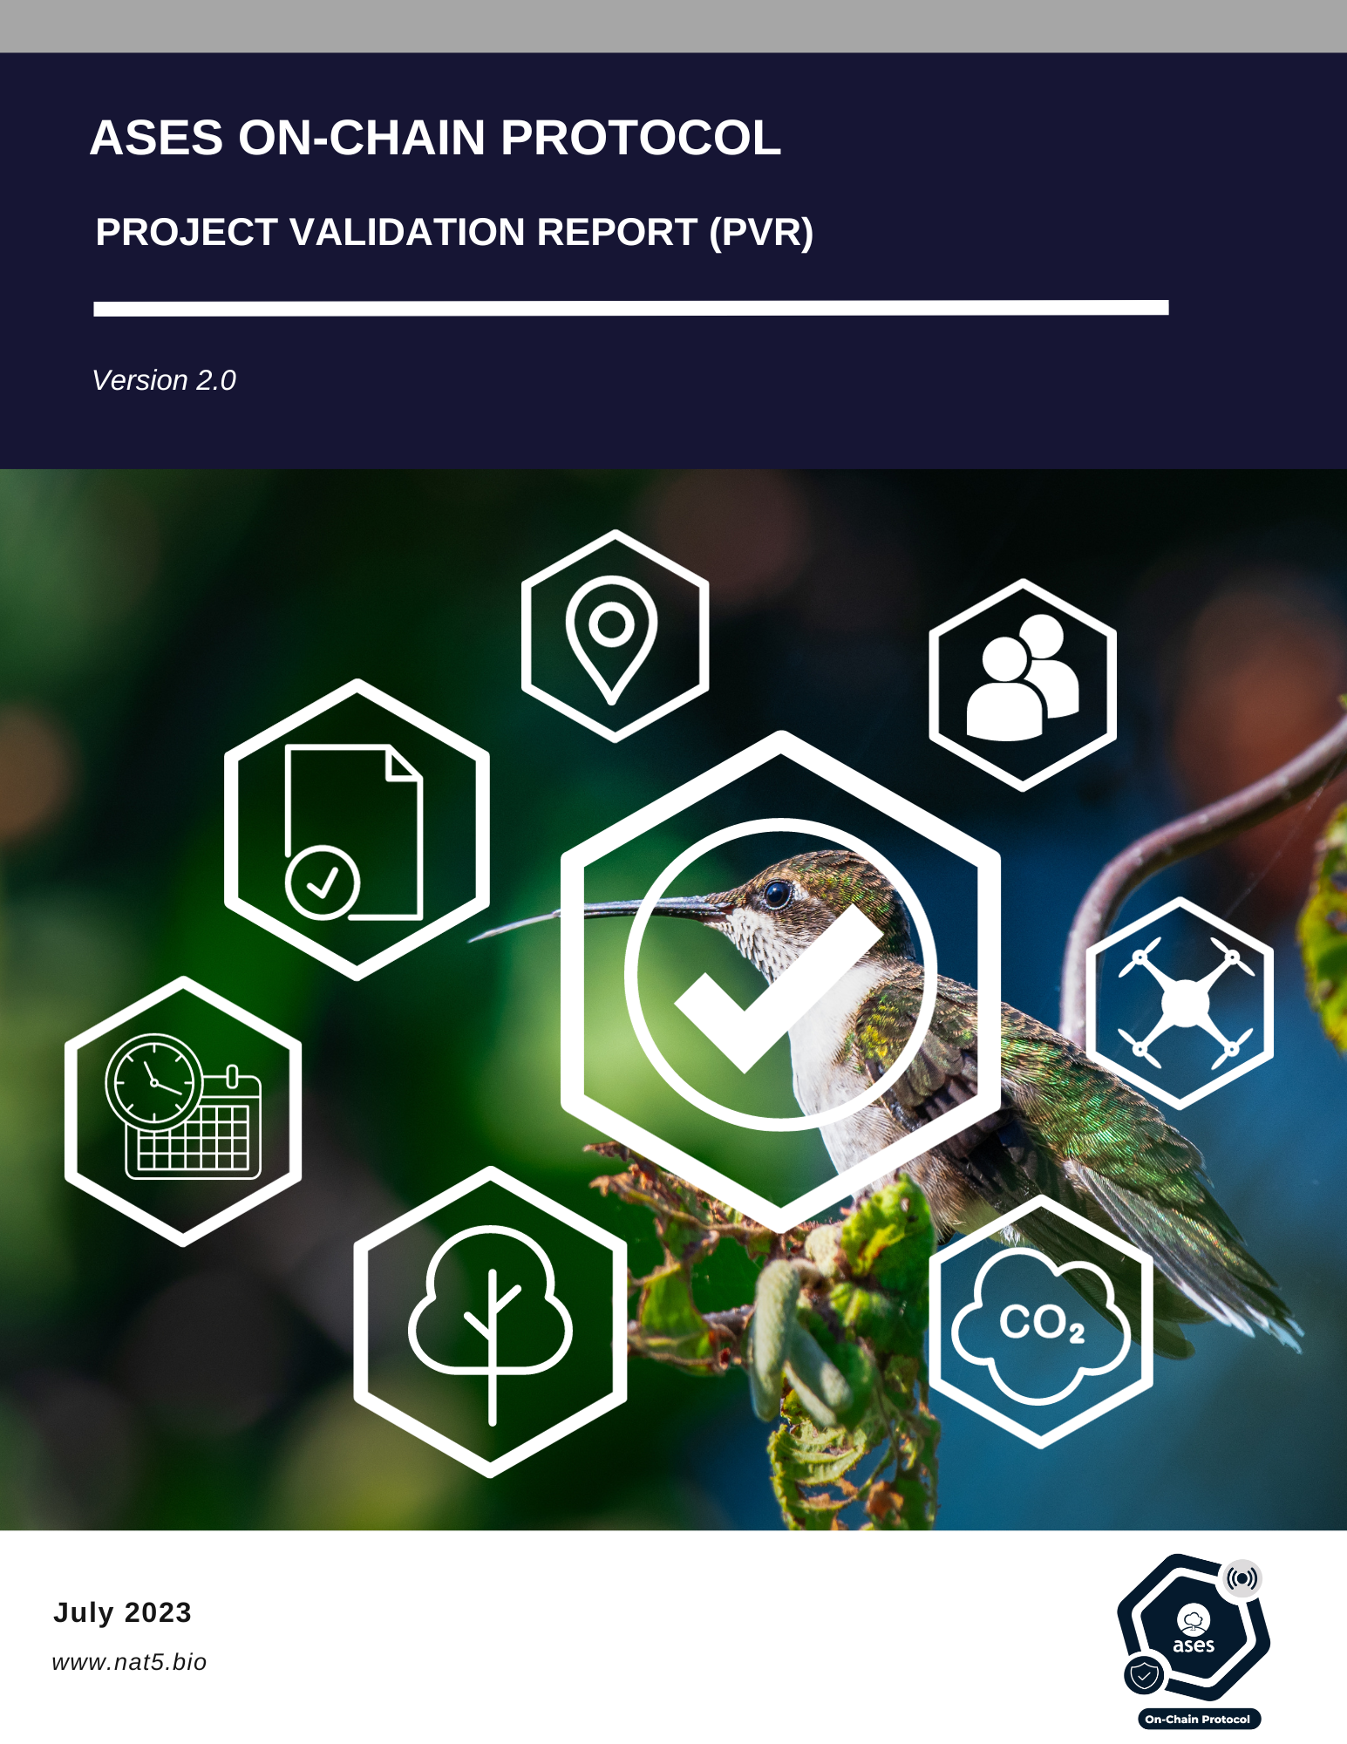

|  |  |
| --- | --- |
| **aOCP Project Validation Report Form (PVR)** | |
| *Complete this form in accordance with the instructions* | |
| **Validator information** | |
| **Name of approved aOCP Project Validator / Reference No.**  (also provide weblink of approved aOCP Certificate) |  |
| **Unique validator/verifier registry key** |  |
| **Project information** | |
| **Title of the project activity** |  |
| **Key project** |  |
| **Project Developer** |  |
| **Project modality** | Modality A  Modality B |
| **Type of project** | Forest management  Regenerative agriculture  Silvopastoral management  Individual tree-based climate action / urban forest  Water flow restoration  Biochar |

|  |  |
| --- | --- |
| **Type of VNPCs the project is applying for** | Carbon Removal and/or Emissions Reduction(VCC)  Biodiversity Based Credit (VBBC)  Water Credits (VWC)  Soil Credits (VSC) |
| **Country(ies) where the project is located** |  |
| **GPS coordinates of the Project site(s)’ centroid (one for each polygon).**  **In WGS84 and decimal degrees format.** |  |
| **Applied methodologies** | aOCP Methodology for water balance assessment V2.0  aOCP Methodology for soil and erosion assessment V2.0  aOCP Methodology for biodiversity assessment V2.0  aOCP Methodology for carbon removal and storage in vegetation V1.0  aOCP Methodology for biochar V1.0  aOCP Methodology for carbon capture monitoring V1.0 |

# Project validation report

## Section A. Executive Summary

## Section B. Involved in the project certification process

Table 1. Involved in the project certification process

|  |  |  |  |  |  |  |  |
| --- | --- | --- | --- | --- | --- | --- | --- |
| **No.** | **Role** | **Last name** | **First name** | **Involvement in** | | | |
| **aOCP Internal team of technical experts** | **Third independent part** | **Project developer** | **aOCP Steering committee** |
| 1. | Validation Team Leader |  |  |  | **✓** |  |  |
| 2. | Leader of the internal team of technical experts | Alejandra | Verde | **✓** |  |  |  |
| 3. | Legal representative of the project developer |  |  |  |  | **✓** |  |
| 4. | Steering committee representative | Guillermo | Hinojos |  |  |  | **✓** |

## Section C. Project Validation findings

Fill out the tables in sections D.1 through D.14 below to verify compliance with the appropriate Project Validation standards in the aOCP Validation and Verification Standard and Project Standard by describing:

* Means of Project Validation: describe how compliance was validated;
* Determine whether or not the project is in compliance.

### D.1. Identification and eligibility of project type

Has the project alignment report been completed? Considering the analysis of:

* Avoidance of environmental and social impacts;
* Additionality;
* Change of land use in the project area.

|  |  |
| --- | --- |
| **Means of Project Validation** |  |
| **Conclusion** | Compliance  In non-compliance |

**D.2. Project compliance with aOCP standards**

Whether proposed aOCP Project Activities comply with aOCP rules and requirements.

|  |  |
| --- | --- |
| **Means of Project Validation** |  |
| **Conclusion** | Compliance  In non-compliance |

**D.3. Notification to the project developer**

In case of non-alignment, was the developer notified and satisfactorily resolved?

|  |  |
| --- | --- |
| **Means of Project Validation** |  |
| **Conclusion** | Compliance  In non-compliance  Not applicable |

**D.4. Land tenure**

Is there a signed agreement between the project developer and the landowner?

|  |  |
| --- | --- |
| **Means of Project Validation** |  |
| **Conclusion** | Compliance  In non-compliance |

**D.5. Project traceability**

Is there evidence of non-participation/registration in another GHG program or other credits of nature made by ASES, or not in the same type of credit?

|  |  |
| --- | --- |
| **Means of Project Validation** |  |
| **Conclusion** | Compliance  In non-compliance |

**D.7. Calculations**

Accuracy of calculations:

* **Carbon removal:** number of carbon credits is not higher than carbon checker;
* **Biodiversity:** was survey done on site? Is there evidence in the monitoring report?
* **Soil erosion:** aOCP's internal team of technical experts performed the survey? is there evidence of the works? does the report include evidence of the data rasters used? and evidence (photographic and cartographic annexes, databases, spreadsheets, reports are clearly presented facilitating the reproducibility of the calculations);
* **Soil health:** were laboratory analysis performed?;
* **Water:** does the report include evidence of the rasters used and the precipitation data? and evidence (photographic and cartographic annexes, databases, spreadsheets, reports are clearly presented facilitating the reproducibility of the calculations).

|  |  |
| --- | --- |
| **Means of Project Validation** |  |
| **Conclusion** | Compliance  In non-compliance |

**D.8. Type of VNPCs the project is applying**

Does the baseline report cover all types of VNPCs requested by the Project developer?

|  |  |
| --- | --- |
| **Means of Project Validation** |  |
| **Conclusion** | Compliance  In non-compliance |

**D.9. Sustainable Development Goals**

Is the SDG reporting supported by indicators to quantitatively monitor the project's contribution?

|  |  |
| --- | --- |
| **Means of Project Validation** |  |
| **Conclusion** | Compliance  In non-compliance |

**D.9. Local Stakeholder Consultation**

Was LSC evidence assessed and presented? In case the evidence is not sufficient, the Validator may conduct telephone, video, mail or email interviews with the landowner.

|  |  |
| --- | --- |
| **Means of Project Validation** |  |
| **Conclusion** | Compliance  In non-compliance |

**D.10. Agreements**

The developer was notified and approved in writing in the contract:

a. Baseline field report;

b. Risk management plan (risk analysis and mitigation program, contingency plan);

c. Contingent credit issuance table and issuance conditions;

d. Nat5 Scoring;

e. Monitoring plan.

|  |  |
| --- | --- |
| **Means of Project Validation** |  |
| **Conclusion** | Compliance  In non-compliance |

**D.11. Evidence of information**

Are the arguments and evidence presented sufficient and of adequate quality? If not, raise Technical Modification Request or Request of Supplementary Information.

|  |  |
| --- | --- |
| **Means of Project Validation** |  |
| **Conclusion** | Compliance  In non-compliance |

# Section D. Validator's opinion

Table 3. Project Validation

|  |  |  |
| --- | --- | --- |
| **Validators name** |  | **Date:** |
| **Validation conclusion** | | |
|  | | |
| **Validator's opinion:** | | |
| **Approved** (The project meets the necessary requirements for certification)  **Not approved** (the validator's opinion is not favorable since the project is not aligned to access certification.  **Additional information** (the information/evidence provided for validation is not sufficient) | | |

|  |
| --- |
| If the project is "not approved" or requires "additional information", please detail the technical justification and the need for additional information. Specify if it is a Technical Modification Request or a Supplementary Information Request. |
|  |

|  |
| --- |
| **Name and signature of validator** |
|  |

|  |  |  |
| --- | --- | --- |
| **DOCUMENT HISTORY** | | |
| **Version** | **Date** | **Comments** |
| V2.0 | 10/10/2023 | * Second version released for review by the aOCP Steering Committee under the aOCP Version 2. |
| V1.0 | 25/01/2023 | * Initial version released for review by the aOCP Steering Committee under the aOCP Version 1. |